Kingdom Life
“Live a Kingdom Life”
Pencil Banner
If the kingdom of God is so different from this world, and Jesus’ truth is so different fro our own ideas, how can you know the truth? You can dive into His world. Ask God to show you His truth. Abide in Jesus, and ask Him to guide you in every part of your day. Ask God to pour out His grace on you so you can live the kingdom life.
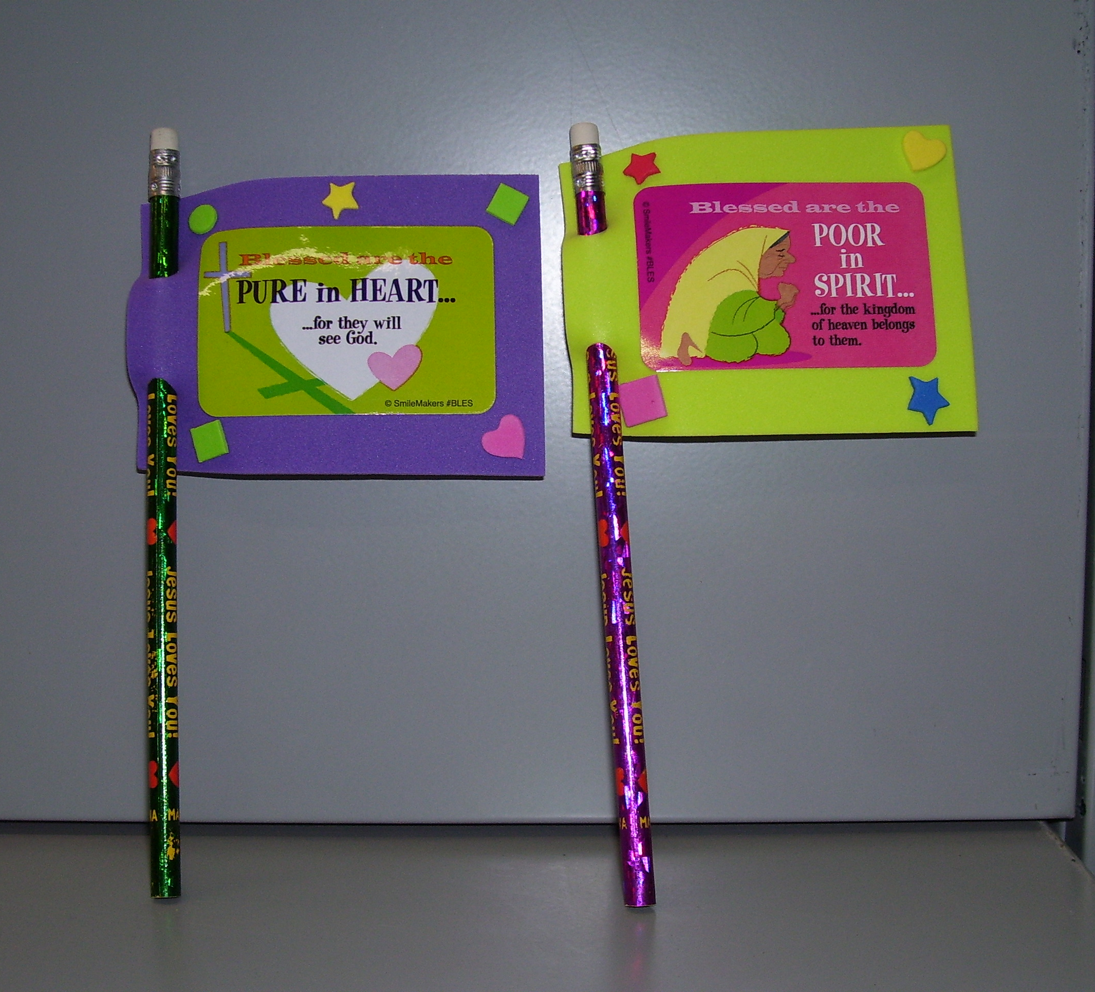

Directions:
- Choose a colored fun foam square
- Punch two holes on one short side for your pencil to go through
- Add one Beatitude sticker (www.smilemaker.com #BLES) to front of banner
- Decorate around the Beatitude sticker with smaller stickers, markers and gel pens
- Add Titus 2:11-12 sticker to back of completed craft

